Implementation Of EDF Scheduler

Name : Basma Ashraf

Email : Basma.ashraf.muhamad@gmail.com

**Analytical Method Verification**

1-System Hyper Period

|  |  |
| --- | --- |
| Task | Periodicity (ms) |
| Button_1_Monitor | 50 |
| Button_1_Monitor | 50 |
| Transmitter | 100 |
| UART | 20 |
| Load_1 | 10 |
| Load_2 | 100 |

Hyperperiod = Least common Multiplier of all Periods

= 100 ms

→that means all task repeats itself every 100ms

2- CPU Load

→We calculate execution time of every task from Keil simulatior using Logic analyzer and cursor.

|  |  |  |
| --- | --- | --- |
| Task | Execution Time | Periodicity |
| Button_1_Monitor | 15 μs | 50 |
| Button_2_Monitor | 14.7 μs | 50 |
| Transmitter | 17,3 μs | 100 |
| UART | 26 μs | 20 |
| Load_1 | 5 ms | 10 |
| Load_2 | 12 ms | 100 |

U = Total Exec. Time during one Hyper-Period / Hyper-Period

= [ (0.013 x 2) + (0.013 x 2) + (0.0173) + (0.0233 x 5) + (5 x 10 ) + (12) ] / 100

= 62.3415 %

2- Schedulability

**Rating Monotonic Utilization Bound**

U ≤ n[ 2 ^ (1/n) -1] ; n→ no. of Tasks

URM = n [2 ^ (1/n) - 1] = 6 [2 ^ (1/6) - 1] = 0.7347

U = Σ C / P = (0.013/50) + (0.013/50) + (0.0173/ 100) + (0.0233 / 20) + (0.05) + (0.12) = 0.621858

Since U < URM, So the system is indeed Schedulable.

**Time Demand Analysis**

Arrangement of Tasks would be.

1- Load 1 → T1

2- UART → T2

3- Button 1 → T3

4- Button 2 → T4

5- Transmitter → T5

6- Load 2 → T6

T1 Calculations

W(1) = 5 + 0 = 5ms

W(10) = 5 + 0 = 5ms

W(10) < D = 5ms < 10ms → T1 is Schedulable

T2 Calculations

W(1) = 23.3μs + (1/10) * 5ms = 0.50233ms

W(5) = 23.3μs + (5/10) * 5ms = 2.5233ms

W(10) = 23.3μs + (10/10) * 5ms = 5.0233ms

W(20) = 23.3μs + (20/10) * 5ms = 10.0233ms

W(20) < 20ms → T2 is Schedulable

T3 Calculations

W(1) = 13 μs + (1/10) * 5ms + (1/20) * 23.3μs = 0.514165ms

W(50) = 13 μs + (50/10) * 5ms + (50/20) * 23.3μs = 25.071ms

W(50) < 50ms → T3 is Schedulable

T4 Calculations

W(50) = 13 μs + (50/10) * 5ms + (50/20) * 23.3μs +(50/50) * 13 μs = 25.084ms

W(50) < 50ms → T4 is Schedulable

T5 Calculations

W(100) = 17.3μs + (100/50) *13 μs + (100/10) * 5ms + (100/20) * 23.3μs +(100/50) * 13 μs = 50.1858ms

W(100) < 100ms → T5 is Schedulable

T6 Calculations

W(100) = 12ms +(100/100)17.3μs + (100/50) *13 μs + (100/10) * 5ms + (100/20) * 23.3μs +(100/50) * 13 μs = 62.1858ms

W(100) < 100ms → T6 is Schedulable

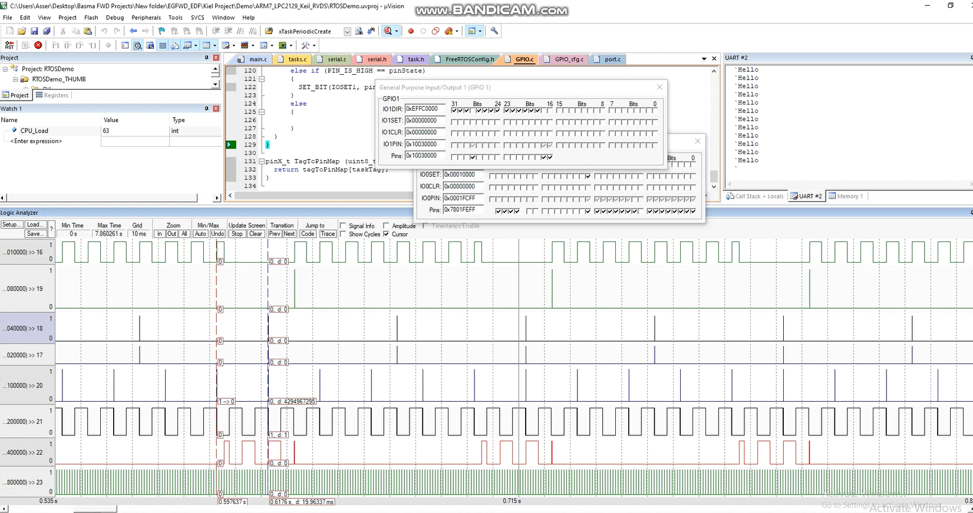

System is schedulable with 62~63% CPU_Load and EDF scheduler is successfully implemented.